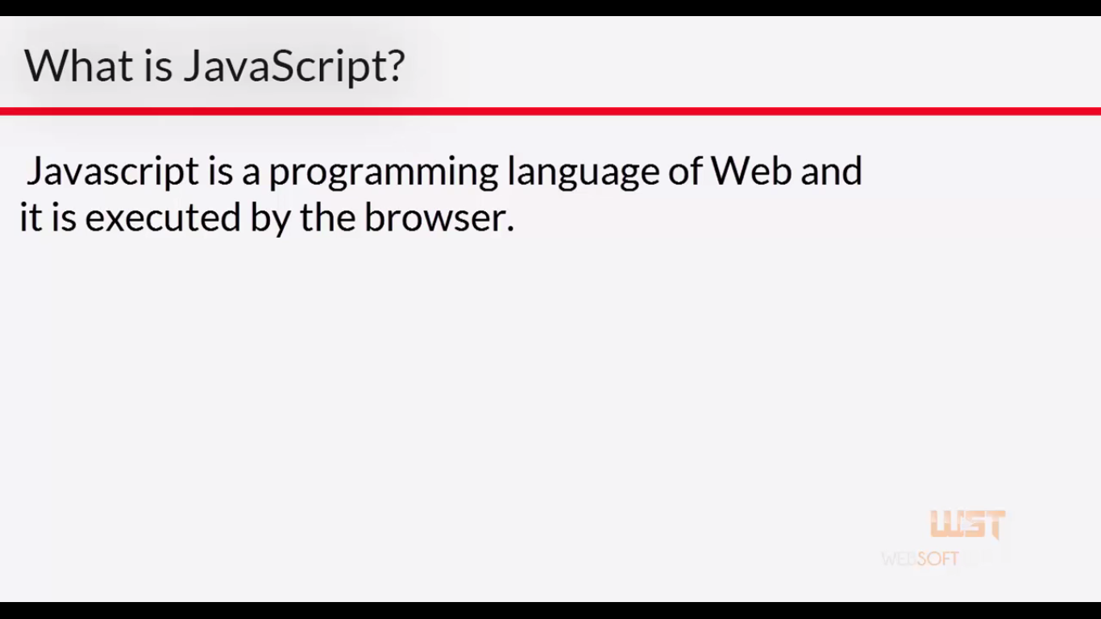

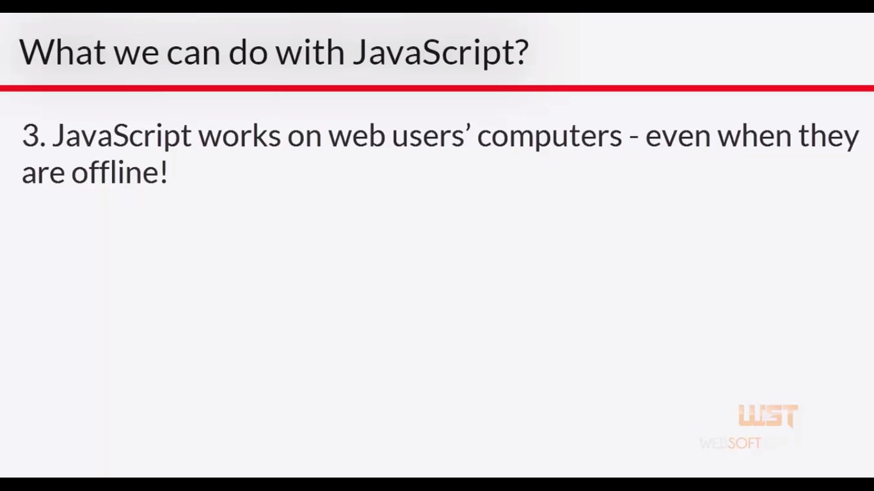

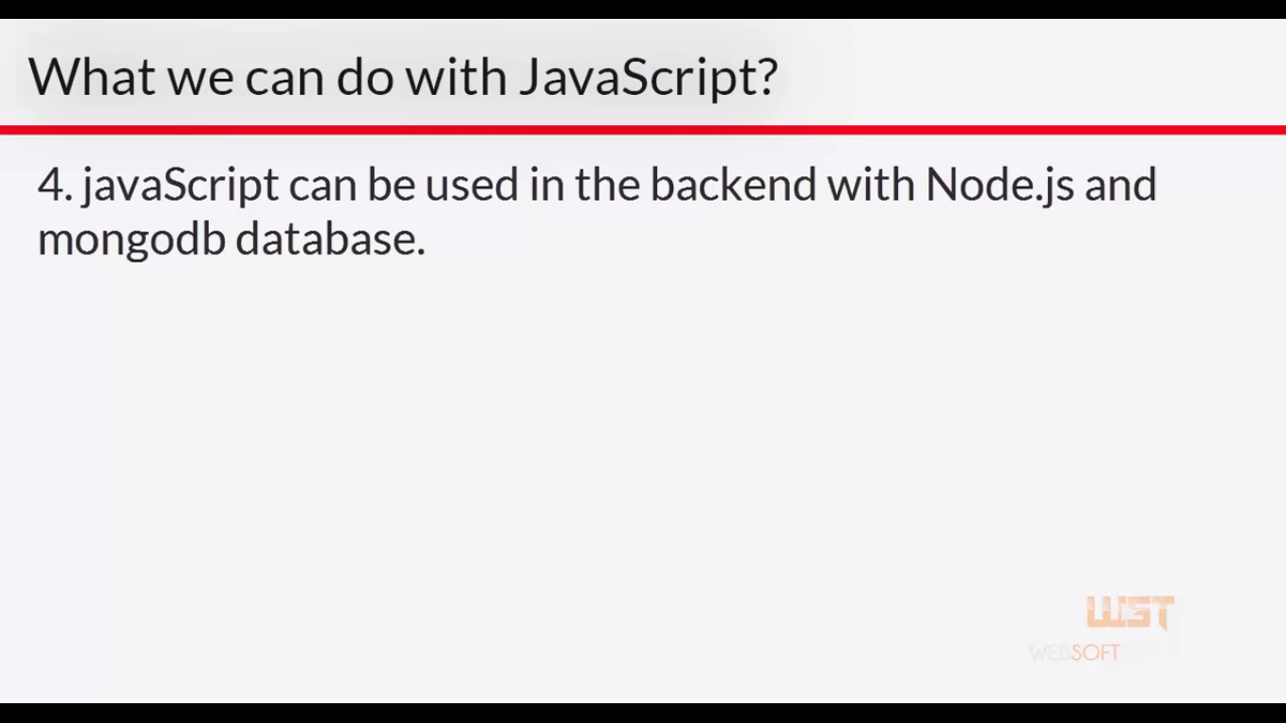

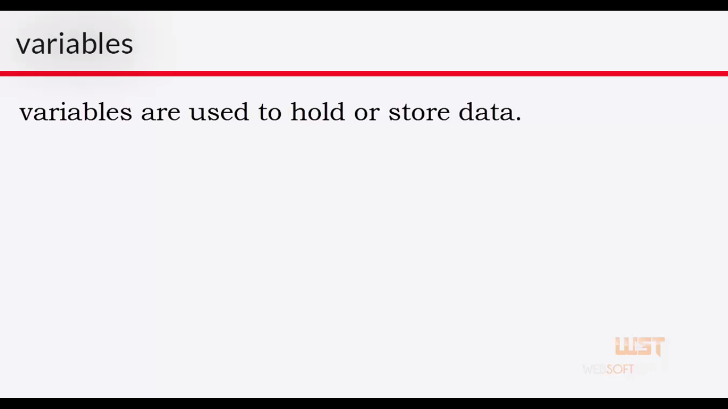**var marks, name, phone;**

**Var marks= 10;**

**Alert(hello);**

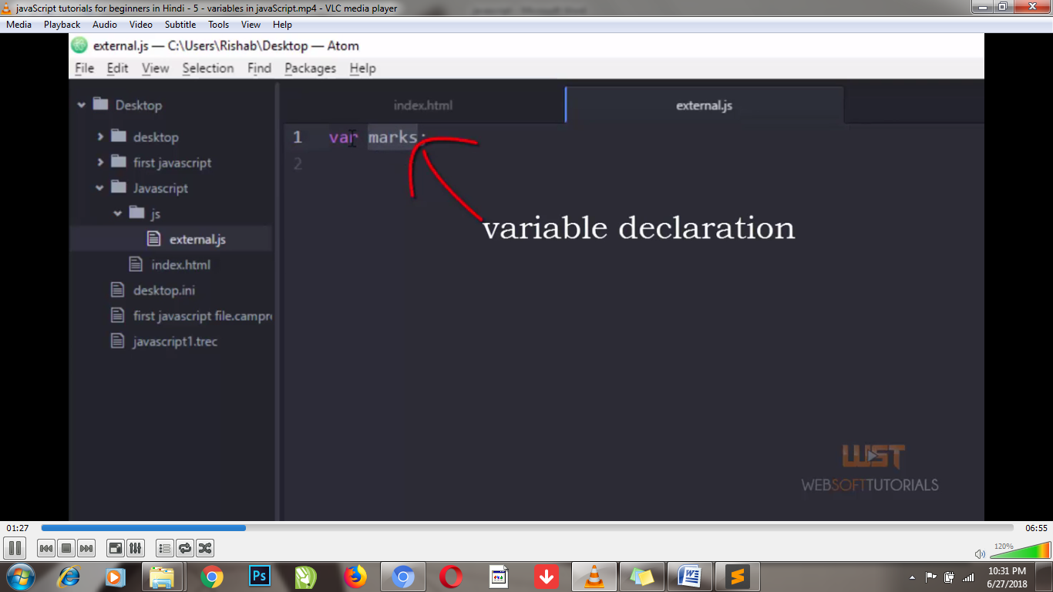

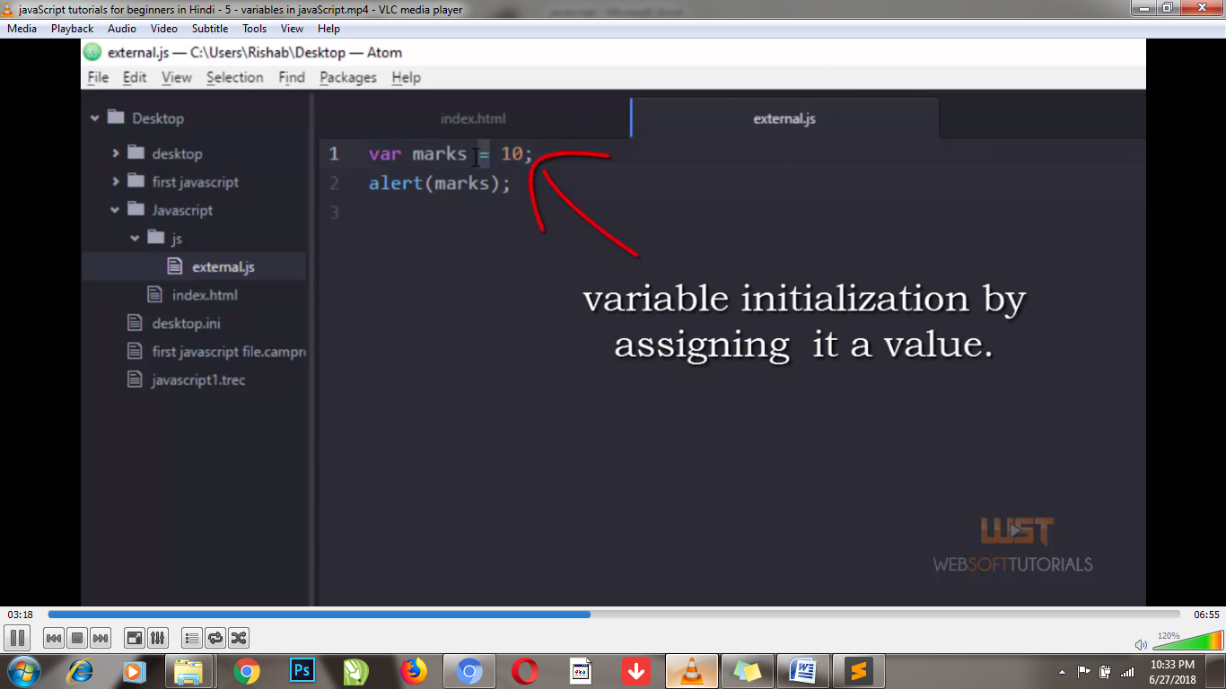

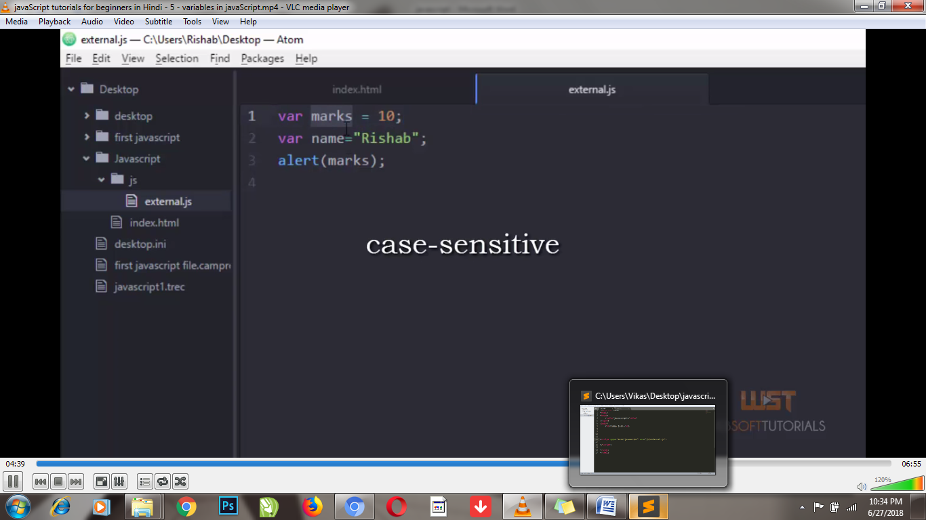

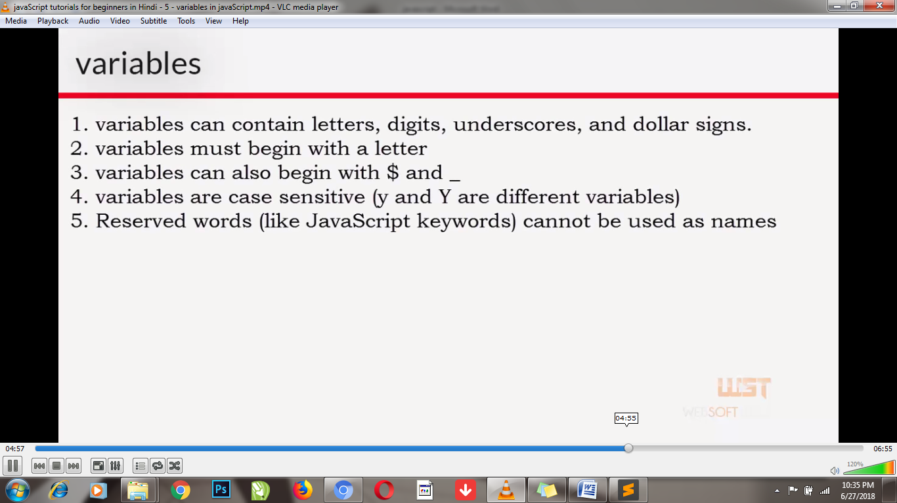

**var marks = 10, name="vikas";**

**alert(name);**

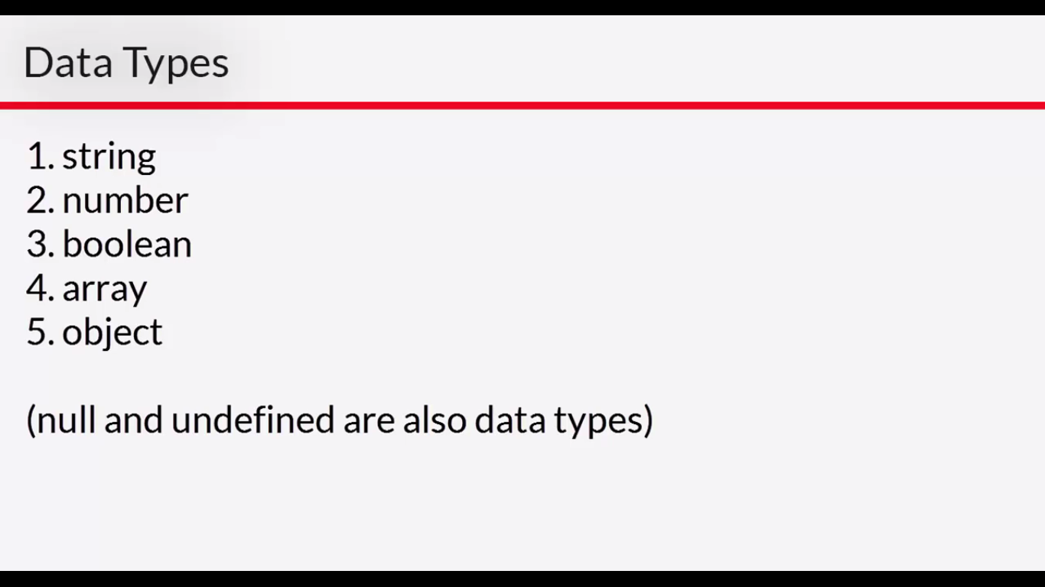

**String:-**

1. **var msg = "vikas";**

**alert(msg);**

1. **Var msg = “vikas ‘jain’ rahul”;**
2. **Var marks =1000;**
3. **Alert(typeof marks);**
4. **Var sum =10+”10”; ans=1010**
5. **Var sum= “10”+10; ans=1010**
6. **Var sum= 10+5+”10”; ans =1510**
7. **Var sum= true; ans= Boolean**

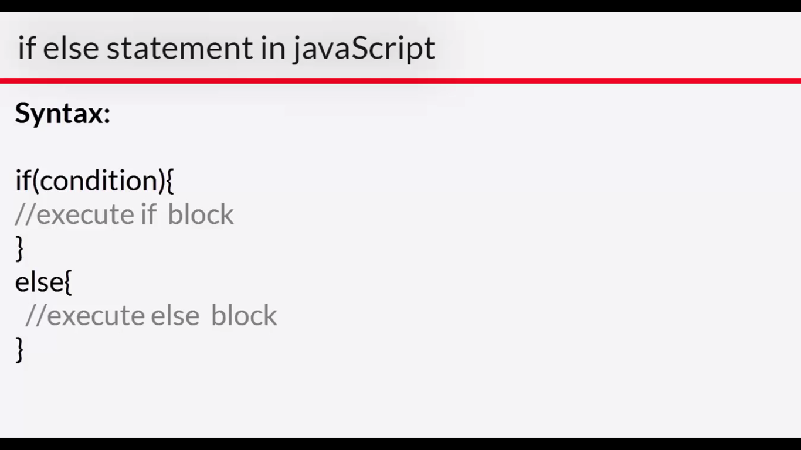

**var a=10;**

**var b=10;**

**if(a==b){**

**alert("value are equal");**

**}**

**else{**

**alert("value are not equal");**

**}**

**Arithmetic Operators:-**

**Var answer = 10+15;**

**Alert(answer);**

**Var answer =5+5*10; ans= 55**

**Var answer=(5+5) * 10; ans=100**

**Var answer= 9;**

**Answer++;**

**Alert(answer); ans=10;**

**Answer--; ans=9;**

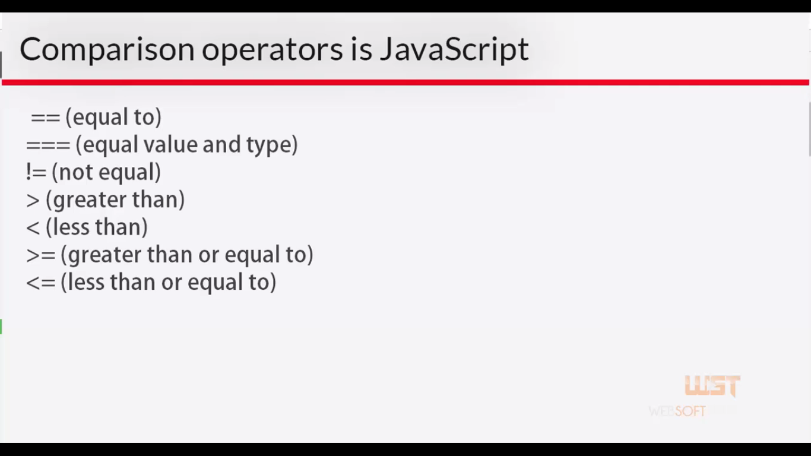

**== & === differentiation**

**=== value ke sath data type bhi check karta h**

**Ex:- var a=10, b=”10”;**

**If(a===b){**

**Alert(“both are same”)**

**{**

**Else{**

**Alert(“both are not same”);**

**}**

**Not Equal:-**

**Var a=10, b=5;**

**If(a!=b)**

**{**

**Alert(“number are not equal”);**

**}**

**Greater than > :-**

**Var a= 10, b=5;**

**If(a>b){**

**Alert(“a is greater”);**

**}**

**Less than < :-**

**Var a=10, b =15;**

**{**

**Alert(“a is smailer”);**

**}**

**Greater than equal To >= :-**

**Var cAge =18;**

**If(cAge >=18)**

**{**

**Alert(“you are eligible for voting”);**

**}**

**Else{**

**Alert(“you are not eligibale for voting”);**

**}**

**Less than Equal To <= :-**

**Var emloyeeAge = 61;**

**If(emloyeeAge<= 60)**

**{**

**Alert(“you should work”);**

**}**

**Else{**

**Alert(“you are eligible for retirement”);**

**}**